1. Endah: What do you think of those shirt?
Rina: I think the red one … than the others.
A. suitabler
B. the most suitable
C. more suitable
D. the suitablest
E. as suitable as

2. X : Di you watch the sport program on TV last night?
Y : Yes, of course. I think Taufik Hidayat will be a champion in the Indonesia Open Tournament.
X : I think so. he played … than before.
A. carefully
B. more carefully
C. the most carefully
D. as carefully
E. be carefull

3. X : I think TV program is … than radio.
Y : i agree with you. TV has audio and visual system.
A. less interesting
B. more interesting
C. worse
D. as bad as
E. the worst

4. Tania : I like the “Galaxy radio” very much. The programs are very interesting.
Vira : I know, it is good, but the “Family Radio” is …
A. good
B. worse
C. better
D. bad
E. worst

5. Andi : We are in hurry. How should we go, Dul?
Dullah : I think motorcycle will be better, because it is … than bike.
A. fast
B. faster
C. slow
D. slower
E. as slow

6. Maman : I have to go to Jakarta tomorrow, but I don’t have enough money to buy a ticket. How can I go there?
Ilyas : You can go there by an economy-class train.
Maman : How about the executive-class?
Ilyas : It’s … the economy-class, but it is more expensive.
A. better than
B. the worst
C. worse than
D. the best
E. good

7. X : How did Andy jog in the race?
Y : he jogged quickly.
X : Really? How about Cendy?
Y : He was the winner. So he jogged …
A. as quickly as the others
B. more quickly than Andy
C. very quickly
D. the quickest of all
E. quicker than others

8. Putri : Was Indonesian team as strong as Japan?
Nanda : No, I think Japan was stronger than Indonesia.
Putri : But …, China, Japan or Indonesia?
Nanda : China.

A. which team is the strongest
B. which team is the weakest
C. which country plays better
D. which country was played better
E. which country plays better

Moro Moro Resto
Foods | Price ( Rp )
Fried rice  Steamed rice  Chicken porridge  Chicken crispy | 20.000  18.000  15.000  12.500

Foods | Price ( Rp )
Hot tea  Ice tea  Black coffee  Lemonade | 5.000  6.000  8.000  7.500

9. The cost of chicken porridge is…… expensive that the steamed rice
A. more
B. less
C. the least
D. the most
E. many

- Fried rice is …….. of all the foods.
- More expensive
- As expensive as
- The most expensive
- Expensive
- The expensivest

- Which of the following statements is true based on the table?
- Ice tea is the cheapest drink
- The lemonade is more expensive than black coffee
- Chicken porridge is as expensive as chicken crispy
- Ice tea has the same price as black coffee
- Chicken crispy is the cheapest food.

12. Clara … flowers every day.
A. buy
B. buying
C. was bought
D. buys
E. bought

13. The cake … by Jennifer yesterday.
A. was buys
B. is buying
C. was bought
D. Bought
E. am bought

(Rameama is sitting with her tribe around a small fire in the heart of the Amazon rainforest. They are gathered to discuss the threat of potential developers.)

Rameama : (speaking with determination) Brothers and sisters, we must stand together to protect our land and the rainforest. Our ancestors have lived here for generations, and it is our duty to preserve our home

Tribal Elder : (nodding) You speak wise words, Rameama. The rainforest is our lifeblood, providing us with food, sheller, and medicines. We cannot let it be destroyed.

Young Warrior : But how can we fight against the developers, Rameama? They have power and resources.

Rameama : (confidently) We may not have their wealth, but we have something more powerful: our unity and connection to the land. We must raise our voices and show the world that we will not allow them to exploit our home

Tribal Elder : Rameama is right. We have faced challenges before and prevailed. We must use our knowledge of the rainforest and our traditions to protect it

Rameama : (looking determinedly at her tribe) Let us gather evidence of the importance of the rainforest, document our history, and share our stories with the world. Together, we can create awareness and build support for our cause.

Young Warrior : And what about the developers? How can we stop them from entering our territory?

Rameama : We will stand as guardians of our land. We will peacefully protest, engage in dialogue with authorities, and seek legal protection. Our determination and resilience will be our strength.

Tribal Elder : (placing a hand on Rameama's shoulder) Rameama, you have grown into a wise and courageous young woman. Your passion for our home is inspiring. We will fight alongside you to protect our rainforest and ensure its preservation for future generations.

(The tribe nods in agreement, their faces filled with determination and hope.)

14. What is the main concern of Rameama and her tribe?

a.) Protecting their land and the rainforest

b. Gaining power and resources
c. Exploiting the developers' wealth

d. Leaving their home and finding a new place

e. Ignoring the threat and doing nothing

15. How does Ramesma believe they can fight against the developers?

a. By using their wealth and resources

b. By giving up and leaving their land

By engaging in violent confrontations

By raising their voices and creating awareness

e. By joining forces with the developers

16. What is the tribe's strength in this battle?

a. Their unity and connection to the land

b. Their wealth and resources

c. Their access to modern technology

d. Their intention to exploit the rainforest

e. Their desire to abandon their traditions

17. What actions does Rameama suggest they take?

a. Ignore the developers and hope they go away

b. Destroy the rainforest to prevent the developers' entry

c. Gather evidence and document the importance of the rainforest

d. Isolate themselves from the outside world

e. Give up and accept the fate of their land

18. How does the tribe plan to protect their land?

a. Through violent confrontations with the developers

b. By surrendering to the developers' demands

c. By peacefully protesting and engaging in dialogue

d. By joining forces with other tribes

e. By allowing the developers to exploit their resources

A Day with a Flat Tire

One sunny afternoon, a boy named Arif decided to ride his bike to the park. He had been looking forward to this all week. As he rode down the street, he felt the wind in his hair and the warmth of the sun on his face. It was the perfect day for a bike ride

Suddenly, Arif heard a loud hissing sound He stopped and looked down to see his front tire going flat. His heart sank. He was still far from 3. the park and didn't have a spare tube or pump with him

Feeling a bit helpless, Arif walked his bike to the side of the road. He remembered his father's advice to always stay calm and think of a solution. Arif decided to walk his bike back home, even though it was a long way.

On his way back, Anif saw his neighbor, Mr. Hasan, working in his garden. Mr. Hasan noticed Anf's flat tire and called out. "Do you need some help? Relieved, Arif explained what had a happened. Mr. Hasan smiled and invited him into his garage

Mr. Hasan had all the tools needed to fix the flat tire. He showed Ant how to remove the wheel, find the hole, and patch it up. Arif watched carefully, grateful for the help. Within a short time, the tire was as good as new.

Arif thanked Mr. Hasan and happily rode his bike home, He had learned something valuable that day: always be prepared and never hesitates to ask for help when needed. Despite the flat tire, It turned out to be a good day after all.

19. What was Arif looking forward to doing all week?

a. Going swimming

b. Riding his bike to the park

c. Playing video games

d. Visiting his grandparents

e. Reading a book

20. What sound, did Arif hear that made him stop his bike?

a. A loud bang

d. A bird chirping

c. A car honking

e. A loud hissing sound

A dog barking

21. How did Arif feel when he saw his tire going flat?

a. Excited

b. Relieved

c. Happy

d. Helpless

e. Angry

22. Who helped Arif fix his flat tire?

His father

b. His best friend

c. His teacher

d. His neighbor, Mr. Hasan

e. A police officer

23. What valuable lesson did Arif learn from this experience?

a. Always carry a book while biking

b. Never ride a bike alone

c. Always be prepared and ask for help when needed

d. Avoid biking on sunny days

e. Keep a spare tire at home

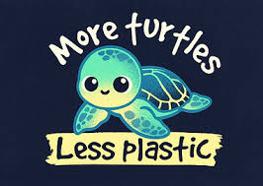

24. What is the main message of the poster?
a. Plastic is good for turtles.
b. Reduce plastic waste to protect turtles
c. Turtles eat plastic to survive.
d. The ocean does not need turtles.
e. More plastic means more turtles.

25. What organization is associated with this poster?
a. Greenpeace
b. Ocean Conservancy
c. World Wildlife Fund
d. Save the Forest
e. Marine Pollution Agency

26. What environmental issue is highlighted in the poster?
a. Deforestation
b. Air pollution
c. Plastic pollution in oceans
d. Global warming
e. Overfishing

27. Why does the poster use the phrase "Less Plastic, More Turtles?
a. To show that turtles eat plastic
b. To encourage people to throw plastic in the ocean
c. To warn that plastic waste threatens turtle survival
d. To promote plastic use for turtle conservation
e. To suggest that turtles are made of plastic

28. How can people support the message of this poster?
a. Continue using single-use plastics
b. Stop eating seafood
c. Reduce plastic use and participate in beach clean-ups
d. Release more turtles into polluted waters
e. Collect plastic waste and throw it back into the ocean

Dina : Have you noticed how polluted the air has become in our city?
Cecil : Yes, it's really concerning. The smog and air quality are getting worse.
Dina : It's affecting our health too. I've been experiencing respiratory Issues.
Ceci :l We need to raise awareness about this issue and advocate for cleaner air.

29. What is the main concern raised by Dina and Cecil?
a. Water pollution
d. Noise pollution
b. Soil erosion
e. Light pollution
c. Air pollution

Rich Dad Poor Dad: Unlocking Financial Wisdom
Rich Dad Poor Dad is a famous book about money written by Robert Kiyosaki it was published in 1997 and tells a special story that teaches us important lessons about handing money
in the book, Kiyosaki talks about his childhood and the two father figures who influenced him his own dad (poor dad) and his best friend's dad (rich dad). His poor dad believed in working hard for a steady job and a regular income. But his rich dad believed in learning about money, investing. and making money work for you. This difference in thinking forms the basis of the book's important ideas
One of the main lessons from Rich Dad Poor Dad is that we need to change the way we think about money. Instead of just working for money, we should aim to be financially independent by starting our own businesses or investing wisely. The book teaches us that having assets that generate income is more valuable than relying on a salary.
The book also emphasizes the importance of understanding money and how it works. Kiyosaki encourages us to leam about money management, investing, arld reading financial statements He belleves that having this knowledge is the key to true wealth.
Another important idea in Rich Dad Poor Dad is about building assets that grow in value and give us passive income. This could mean investing in real estate, stocks, or even starting our own business, Kiyosaki tells us that focusing on these kinds of assets will help us achieve long-term financial SUCCESS.
Lastly, the book talks about the difference between assets and liabilities. Kiyosaki challenges the traditional idea that a house is always an asset. He advises us to minimize our liabilities, which are things that cost us money, and focus on acquiring assets that make us money.
In conclusion, Rich Dad Poor Dad is a book that teaches us valuable lessons about money in a simple and engaging way. By following its advice, we can change our thinking about money. team how to manage it wisely, and start building a strong financial future.

30. What does the book emphasize about assets and liabilities?
a. Houses are always considered assets.
b. Liabilities are things that make us money.
c. Assets are things that cost us money.
d. Acquiring liabilities is the key to financial success.
e. Minimizing assets is important for building wealth.

31. What is one of the main lessons from "Rich Dad Poor Dad"?
a. Working hard for a regular income is the key to financial success.
b. Money management and investing are not important for building wealth.
c. Relying on a salary is the best way to achieve financial independence.
d. Building assets that generate income is more valuable than working for money.
e. Financial statements are unnecessary for understanding money.

32. According to the book, what is the difference between rich dad and poor dad's thinking?
a. Rich dad believes in working hard, while poor dad believes in investing.
b. Poor dad believes in starting a business, while rich dad believes in a regular job.
c. Rich dad believes in learning about money, while poor dad believes in saving.
d. Poor dad believes in building assets, while rich dad believes in minimizing liabilities.
e. Rich dad believes in a steady income, while poor dad believes in passive income.

33. Who is the author of the book "Rich Dad Poor Dad"?
a. Richard Kiyosaki
b. Robert Kiyosaki
rick dadson
Ronald Kiyosaki
Roger Davidson

34. What is the author's advice regarding Financial Independence?
a. Rely on a regular job for a steady income
b. Avoid learning about money management and investing.
Start your own business to achieve financial independence
d. Focus on acquiring liabilities instead of assets.
e. Change your thinking about money and make money work for you

35. Why does Kiyosaki encourage people to learn about money management, investing, and financial statements?
a. Because understanding money is the key to real wealth.
b. Because schools already teach enough about money.
c. Because it helps people, spend more easily.
d. Because liabilities are more important than assets.
e. Because working hard is not necessary at all.

36. According to the book, what kind of income should people aim for to achieve long-term success?
a. Income from liabilities.
b. Passive income from growing assets.
c. Only salary from jobs.
d. Money from borrowing.
e. Gifts from others.

37. What traditional idea does Kiyosaki challenge about houses?
a. That houses always cost nothing to maintain.
b. That houses are liabilities if they cost money
c. That houses never lose value.
d. That houses should be rented, not bought.
e. That houses are always assets.

38. How does "Rich Dad Poor Dad" present its financial lessons?
a. Through complicated formulas.
b. By giving lists of stock tips.
c. Through a story about the author's two father figures.
d. By only talking about real estate.
e. By using government reports.

39. What does the book suggest about changing our mindset toward money?
a. Keep thinking that working for money is enough.
b. Focus on saving only and avoid investing.
c. Learn to make money work for you instead of just working for money.
d. Borrow money to buy liabilities.
e. Avoid building assets to reduce risk.

40. Among all my friends. David is the … at managing his finances.
a. good
b. better
c. best
d. more good
e. goodest

41. This budgeting app is ... than the one I used before.
a. useful
b. more useful
c. most useful
d. usefuller
e. usefullest

42. My brother spends money... than I do.
a. recklessly
d. recklesser
b. more recklessly
e. recklessest
c. most recklessly

43. Of all the tips I've learned, tracking expenses is the ... one.
a. important
b. more important
c. most important
d. importantly
e. importantest

44. Jake tries to invest his money … than before
a. smartly
b. smarter
c. smartest
d. more smartly
e. smartlier

45 | 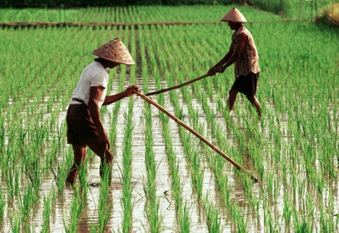
 | A. | They are planting paddies.
 | B. | They are harvesting together.
 | C. | They are planting some trees.
 | D. | They are working in the rice field.
 | E. | They are releasing the traditional machine.

46. | 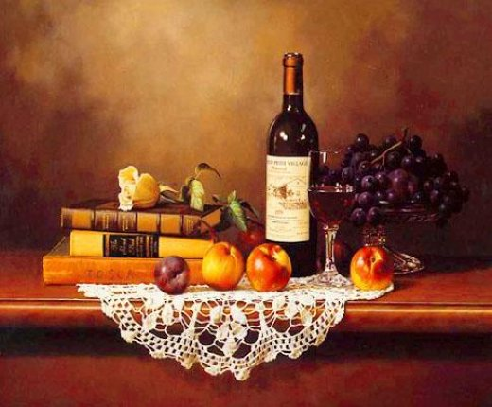
 | A. | There are lots of stuff on the table.
 | B. | The apples are on the top of the books.
 | C. | There is a bucket of flowers on the books.
 | D. | There are few books, fruits and salads.
 | E. | There are many attires on the table.

47. | 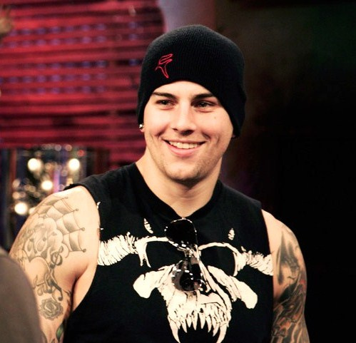
 | A. | The man has skinny body.
 | B. | He is wearing sun glasses.
 | C. | The man is smiling sadly.
 | D. | The man is wearing a formal suit.
 | E. | He is wearing something to cover his head.

48. | 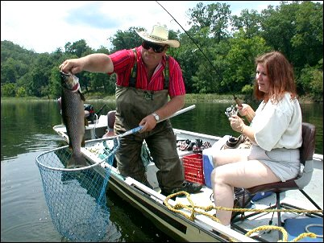
 | A. | The man on the boat is catching the big fish.
 | B. | The woman is standing on the left side of the boat.
 | C. | The woman is catching the fish with the strong power.
 | D. | They are paddling the boat slowly to catch the big fish.
 | E. | They are sitting together on the boat and watching the view.

49. | 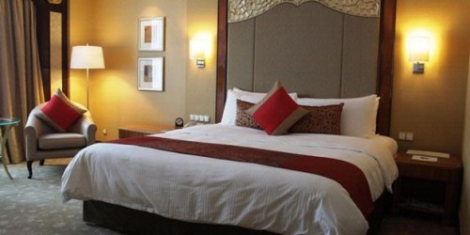
 | A. | Many pictures are hang on the wall
 | B. | There is a pillow on the chair.
 | C. | The cushions and bolsters are on the bed
 | D. | The lamps are close to the wardrobe.
 | E. | There is no any blanket in that room.

50. Two days ago, Karita …. an accident.
- Get
B. Got
C. Gets
D. Getting
E. Have got

